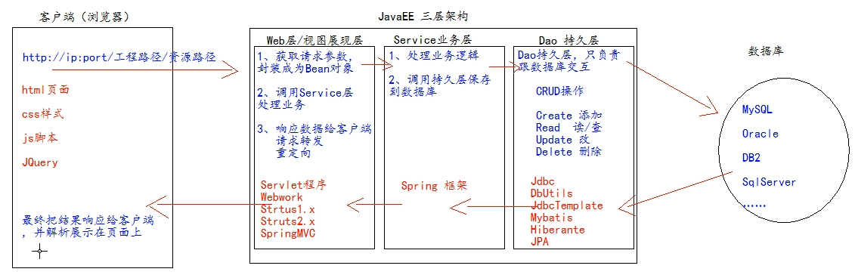

web 层 com /servlet/controller

service 层 com.service Service 接口包

com.service.impl Service 接口实现类

dao 持久层 com. dao Dao 接口包

com. dao.impl Dao 接口实现类

实体bean对象 com. pojo/entity/domain/bean JavaBean 类

测试包 com. test/junit

工具类 com.utils